1.3.6 Packet Tracer - Configure SSH
Addressing Table

Device | Interface | IP Address | Subnet Mask
S1 | VLAN 1 | 10.10.10.2 | 255.255.255.0
PC1 | NIC | 10.10.10.10 | 255.255.255.0

Objectives
Part 1: Secure Passwords
Part 2: Encrypt Communications
Part 3: Verify SSH Implementation

Background
SSH should replace Telnet for management connections. Telnet uses insecure plain text communications. SSH provides security for remote connections by providing strong encryption of all transmitted data between devices. In this activity, you will secure a remote switch with password encryption and SSH.

Instructions

Part 1: Secure Passwords
- Using the command prompt on PC1, Telnet to S1. The user EXEC and privileged EXEC password is cisco.

PC1 > Desktop > Command Prompt  C:\>telnet 10.10.10.2  Password: cisco  S1>enable  Password: cisco | 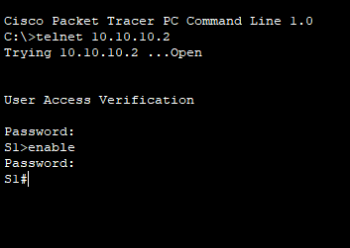

- Save the current configuration so that any mistakes you might make can be reversed by toggling the power for S1.

S1#copy running-config startup-config  Destination filename [startup-config]? Press Enter | 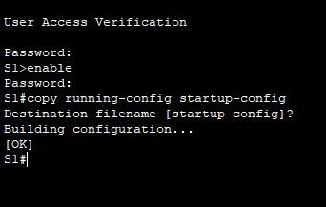

- Show the current configuration and note that the passwords are in plain text. Enter the command that encrypts plain text passwords:
S1(config)# service password-encryption

S1#show running-config | 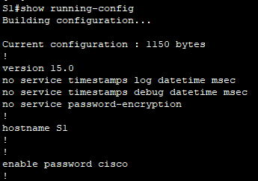
S1#configure terminal  S1(config)#service password-encryption | 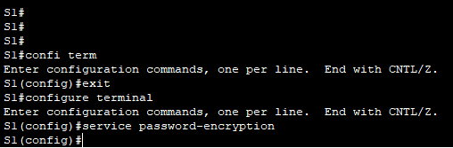

- Verify that the passwords are encrypted.

S1(config)#exit  S1#show running-config | 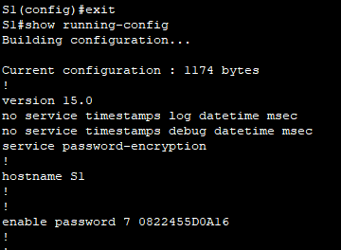

Part 2: Encrypt Communications

Step 1: Set the IP domain name and generate secure keys.
It is generally not safe to use Telnet, because data is transferred in plain text. Therefore, use SSH whenever it is available.
- Configure the domain name to be netacad.pka.

S1#configure terminal  S1(config)#ip domain-name netacad.pka | 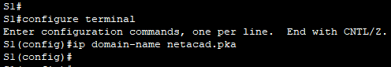

- Secure keys are needed to encrypt the data. Generate the RSA keys using a 1024 key length.

S1(config)#crypto key generate rsa  How many bits in the modulus [512]: 1024 | 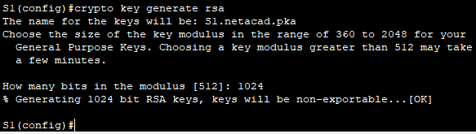

Step 2: Create an SSH user and reconfigure the VTY lines for SSH-only access.
- Create an administrator user with cisco as the secret password.

S1(config)#username administrator secret cisco | 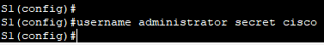

- Configure the VTY lines to check the local username database for login credentials and to only allow SSH for remote access. Remove the existing vty line password.

S1(config)#line vty 0 15  S1(config-line)#login local  S1(config-line)#transport input ssh  S1(config-line)#no password cisco | 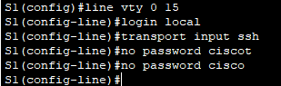

Step 3: Verify SSH Implementation
- Exit the Telnet session and attempt to log back in using Telnet. The attempt should fail.

S1(config-line)#exit  S1(config)#exit  S1#exit  [Connection to 10.10.10.2 closed by foreign host]  C:\>telnet 10.10.10.2  [Connection to 10.10.10.2 closed by foreign host] | 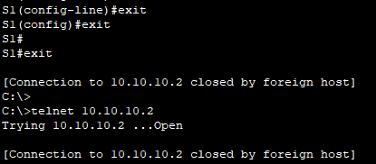

- Attempt to log in using SSH. Type ssh and press Enter without any parameters to reveal the command usage instructions. Hint: The -l option is the letter “L”, not the number 1.

C:\>ssh  C:\>SSH -l administrator 10.10.10.2  Password: cisco  S1>enable  Password: cisco | 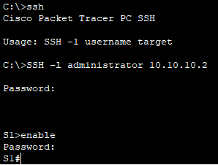

- Upon successful login, enter privileged EXEC mode and save the configuration. If you were unable to successfully access S1, toggle the power and begin again at Part 1.

S1#copy running-config startup-config  Destination filename [startup-config]? Press Enter | 